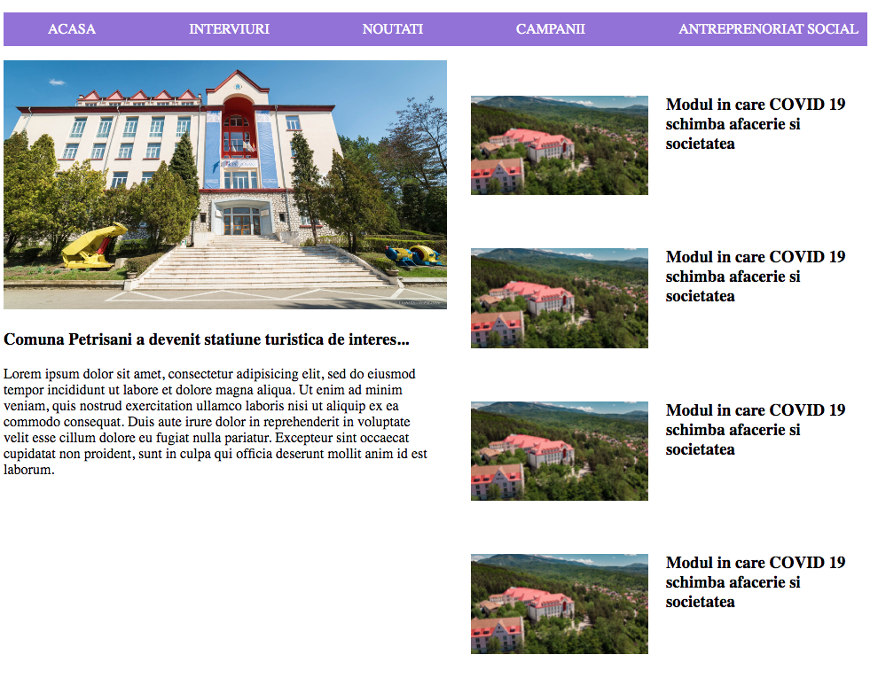

<!DOCTYPE html>

<html>

<head>

<meta charset="utf-8">

<title>Test</title>

<style>

ol{

list-style-type: none;

display: flex;

justify-content: space-between;

background-color: mediumpurple;

}

li{

padding: 10px;

}

li:hover{

background-color: purple;

}

a{

color: #fff;

text-transform: uppercase;

text-decoration: none;

}

#centru {

display: flex;

}

#stanga{

width: 50%;

}

#stanga img{

width: 500px;

}

.info img{

width: 200px;

margin: 20px;

}

.info{

display: flex;

margin: 20px;

}

</style>

</head>

<body>

<header>

<ol>

<li><a href="#">Acasa</a></li>

<li><a href="#">Interviuri</a></li>

<li><a href="#">Noutati</a></li>

<li><a href="#">Campanii</a></li>

<li><a href="#">Antreprenoriat Social</a></li>

</ol>

</header>

<div id="centru">

<div id="stanga">

<img src="https://www.upet.ro/images/homeslide/upSlide002.jpg">

<h3>Comuna Petrisani a devenit statiune turistica de interes...</h3>

<p>Lorem ipsum dolor sit amet, consectetur adipisicing elit, sed do eiusmod

tempor incididunt ut labore et dolore magna aliqua. Ut enim ad minim veniam,

quis nostrud exercitation ullamco laboris nisi ut aliquip ex ea commodo

consequat. Duis aute irure dolor in reprehenderit in voluptate velit esse

cillum dolore eu fugiat nulla pariatur. Excepteur sint occaecat cupidatat non

proident, sunt in culpa qui officia deserunt mollit anim id est laborum.</p>

</div>

<div id="dreapta">

<div class="info">

<img src="https://cronicavj.ro/wp/wp-content/uploads/2020/07/1-9.jpg">

<h3>Modul in care COVID 19 schimba afacerie si societatea</h3>

</div>

<div class="info">

<img src="https://cronicavj.ro/wp/wp-content/uploads/2020/07/1-9.jpg">

<h3>Modul in care COVID 19 schimba afacerie si societatea</h3>

</div>

<div class="info">

<img src="https://cronicavj.ro/wp/wp-content/uploads/2020/07/1-9.jpg">

<h3>Modul in care COVID 19 schimba afacerie si societatea</h3>

</div>

<div class="info">

<img src="https://cronicavj.ro/wp/wp-content/uploads/2020/07/1-9.jpg">

<h3>Modul in care COVID 19 schimba afacerie si societatea</h3>

</div>

</div>

</div>

</div>

</body>

</html>